**COMP90007 Internet Technologies**

**Project 1 – Network Analysis**

**Handan Yu**

**HANDANY**

**1235484**

**Section 2**

**Ans 2.1**

**Meaning of parameters:**

* n: Prints hop addresses numerically rather than symbolically and numerically. This flag saves a name-server address-to-name look up for each gateway found on the path.
* w: Sets the time(in seconds) to wait for a response to a probe
* 1: the time to wait for a response to a probe is 1 seconds

**Importance of parameters:**

* n: Using IP can increase the speed of implementation, since it can reduce the time of host name resolution.
* w 1: Save test time

**Ans 2.2**

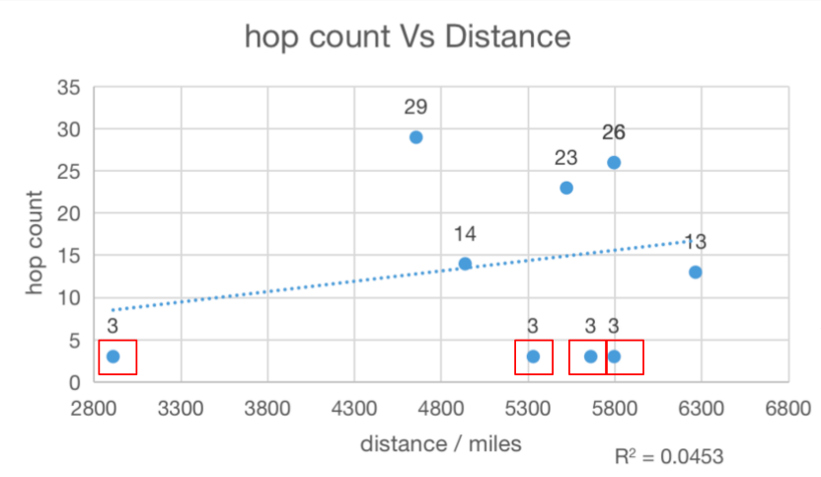

Fig. 2.2.1

I firstly found out the physical geographical distance using a combination of applications available online[1][2], and then detected the hop count of each host using command ‘traceroute’. According to Fig. 2.2.1, there is no an obvious correlation between hop count and distance, though from this figure, it seems that the number of hop decreases due to increasing distance. Since, the sample points I circled with red box might be outliers, in other words, it is time out or failure to detect these four hosts using ‘traceroute’ . Except these four hosts, these is also no exactly correlation between them. The main reason of such scenario I can think about is that there are several kinds of routing algorithm and each of them has different effects on network and router resources, and therefore sometimes the best route will change according to different situations like collisions.

**Section 3**

**Ans 3.1**

Looking at Fig <3.1.1>, <3.1.2>,<3.1.3>, and the experiment results and calculated results achieved in section 3 of the appendix.

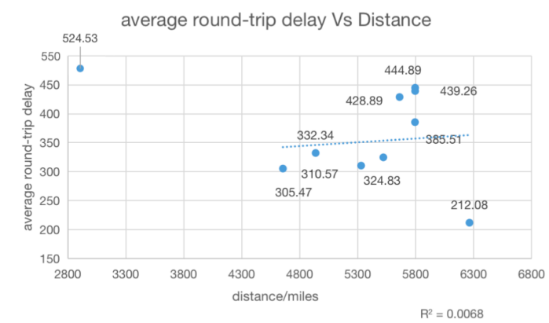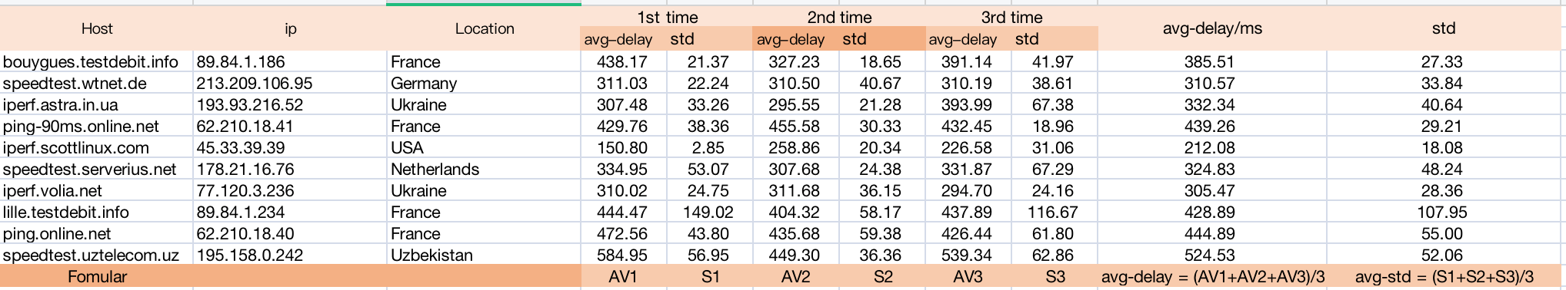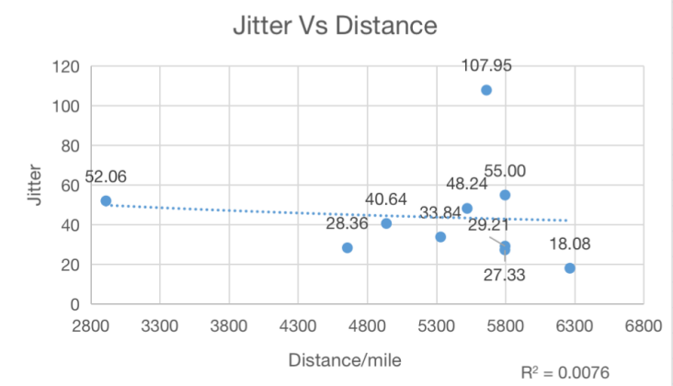Fig. 3.1.1

Fig. 3.1.2 Fig. 3.1.3

Firstly, I recorded all of results including average delay and standard deviation of each round-trip using command ‘ping’ from my experiments and then computed the delay and jitter by averaging round-trip delays and standard deviations of three experiments. The experiment results and calculated results are shown in Fig. 3.1.1.

After drawing the relationships between average round-trip delay and physical geographical distance, and between round-trip jitter and physical geographical distance respectively, I found that the round-trip delay might increase with the growth of distance. As for the correlation of Jitter and distance, it is reluctant to say that there is a inverse proportion between them.

Although these experiment results indicate these two coarse correlations, the correlations are quite faint, since geography by itself cannot provide any information about many performance characteristics like bandwidth, congestion along a path[3].

**Ans 3.2** Looking at Fig <3.2.1> and the result achieved in section 3 of the appendix A.

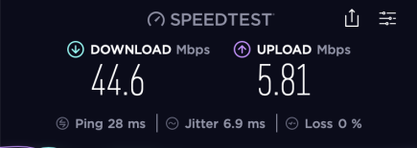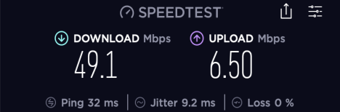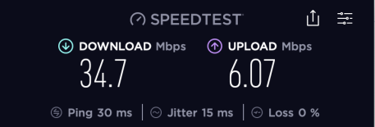

Fig. 3. 2.1

I test my network environment using application **Speedtest** three times, and then average these results I can get my network environment shown in following table.

|  |  |
| --- | --- |
| The download speed | 42.80 Mbps |
| The upload speed | 6.127 Mbps |

Also, in this experience the number of people sharing my network is 2.

The main networking environment that influence my results obtained might be my network occupancy and network bandwidth. To be concrete, when the available network occupancy is less (i.e., network usage is too high), it easily lead to delay. Also, when the network bandwidth is insufficient, it will still cause delay. In other words, there are multiple application need to transmit data at the same time, whereas the maximum of bandwidth is limited, so that it will cause a large amount of data loss and which will behave as a delay.

**Section 4**

**Ans 4.1** Looking at Fig <4.1.1> and the result achieved in section 4 of the appendix A.

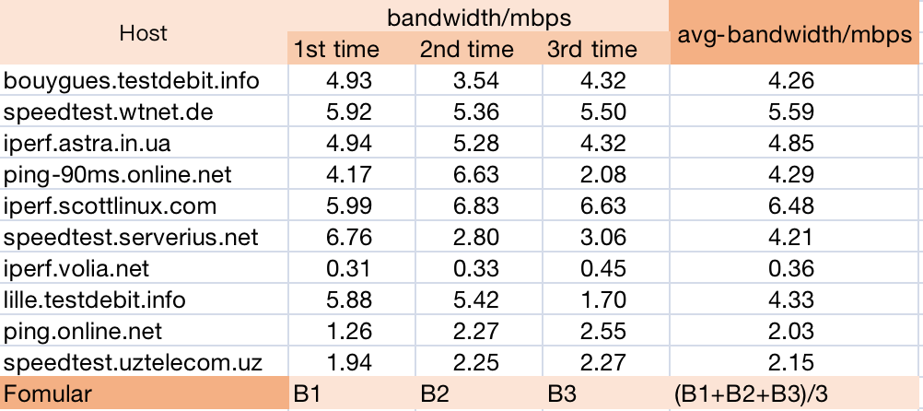

Fig. 4.1.1

Fig. 4.1.1. indicates the three set of measurements results of bandwidth for all these 10 hosts and also demonstrates the average bandwidth for each host by averaging these three experimental results respectively.

The bandwidth-delay product refers to the product of a data link's capacity (i.e., bandwidth) and its end-to-end delay. The bandwidth then refers to the link speed and the delay refers to what the network would like to account for. Consequently, the bandwidth-delay product is the maximum number of bits that can be transmitted by the sender during a given time in the link.

**Ans 4.2** Looking at Fig <4.2.1> and the result achieved in section 4 of the appendix.

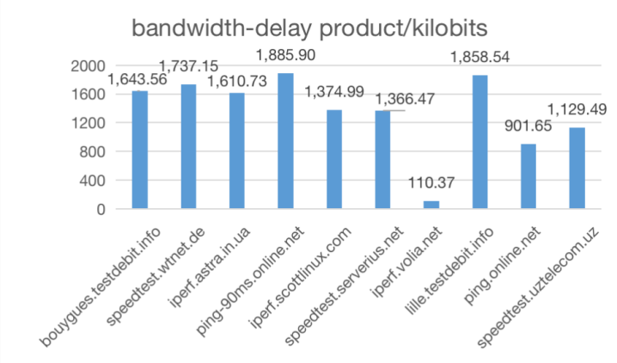

Fig. 4.2.1

**Note: I will use abbreviation of bandwidth-delay product, BDP in this section.**

**Comparative Analysis**: This figure indicates that the majority of hosts’ bandwidth-delay product achieve over 1300 kbits. Whereas, the BDP of host ‘iperf.volia.net’ was only up to 110 kbits. The reason why I obtain the results without any regularities might be that I split several times to accomplished this experiment, so that during each time I implemented different types of applications, which will result different results. Because different types of applications occupy different amount of network bandwidth.

**Reflection of actual internet link speed**: As we can see from the figure 4.2.1, the bandwidth-delay product of each host is relatively high. Meanwhile, the delay of each host shown in is not long. Also, the bandwidth-delay product is the product of data link’s capacity and delay time, where with the increasing of data link occupancy, the data link speed will be increase at the same time. Additionally, taking the relationship between data link speed and delay time into consideration (i.e., the increasing of data link speed indicates that the delay time will be shorten), we can easily obtain the regularity that the larger BDP refers to the higher data link speed.

**The influence of results due to my network environment**: Just as comparative analysis says, I make this experiment several round-trips and also during each round-trip I use different kinds of application simultaneously. Hence I gain different results of each turn. Although I computed their average values, the differences among these hosts cannot be avoided. For instance, I tested the bandwidth-delay of hosts ‘iperf.volia.net’ and ‘ping.online.net’ at the same time. Therefore, their BDP are lower than the others.

**Outliers**: I think the result of host ‘iperf.volia.net’ might be an outlier. The value of its bandwidth is very different from others’. Considering that when I tested the other one simultaneously might occupy a part of bandwidth, so that the rest available bandwidth is insufficient.

**Ans 4.3** Looking at Fig <4.3.1> and the result achieved in section 4 of the appendix

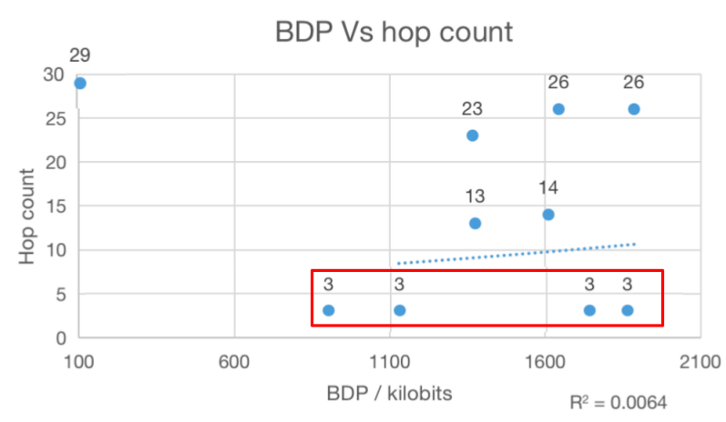

Fig. 4.3.1

From this figure, there is a vague relationship that with the higher BDP, the count of hop is increasing. However, this correlation is not apparent. Since, we can obviously so that when the BDP is up to 1500kbits, there are large number of hop can be detected in some hosts and still small number of hop be found in another hosts.

As for the reasons, theoretically the number of hops increases, the end-to-end segment loss probability increases, resulting in a smaller congestion window size, and hence a large end-to-end delay[4]. So that the BDP might increase due to increasing number of hops. The four points I cycled in red might be outliers, according to the testing results shown in appendix, the hop count testing using traceroute is fail, as all of these four hosts cannot be detected another hops after the certain two hops. So that it is hard to find a specific correlation between BDP and hop count through this experiment result.

**Ans 4.4** Looking at Fig <4.4.1> and the result achieved in section 4 of the appendix.

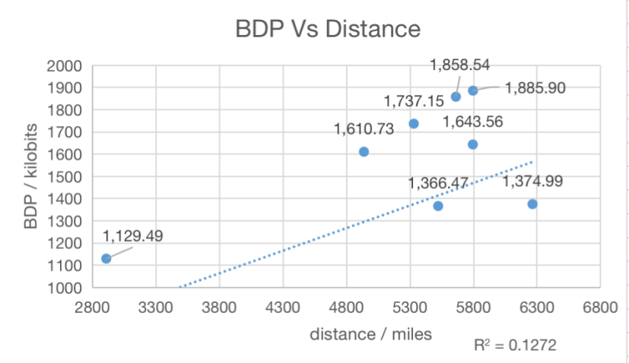

Fig. 4.4.1

From this figure, we can easily find that the value of BDP grows up with the increase of distance. Since, according to the correlation of delay and geography distance detected in Section 3 (i.e., the longer geography distance means the higher delay), plus BDP is the product of data link’s capacity and delay. So, when the data link’s capacities of all hosts are similar, the extending the geography distance between the sender to the sever will lead to improve the value of BDP.

**Ans 4.5**

During my experiment, I think the usage of my network including the number of people sharing my network and the number of application executed at the same time will be the major interference factors. Since, it will directly affect the available bandwidth of my network. Also, the geography location might be another variable that will influence my experiment results. As the geographic location of a source indirectly determines its network connectivity[3].

In order to improve these problems, I think it is necessary to stay my network environment the same as soon as possible during the experiment. Because controlling variables is of great importance in experiments.

**References**

[1] dpip. IP geolocation API and database. <https://db-ip.com/>

[2] FreeMapTools. How Far is it Between. <https://www.freemaptools.com/how-far-is-it-between.htm>

[3] Subramanian, L. , Arasu, A. , Badrinath, B. R. , Baker, M. , & Wood, D. . (2002). On inferring the geographic properties of the internet. Masters Thesis.

[4] Lifeng Zhang & Celimuge Wu &Tsutomu Yoshinaga & Xianfu Chen & Tutomu Murase & Yusheng Ji, 2017 ‘Multihop Data Delivery Virtualization for Green Decentralized IoT’, Wireless Communications and Mobile Computing, vol. 2017, [https://doi.org/10.1155/2017/9805784]( https:/doi.org/10.1155/2017/9805784).

**Appendix**

Section 2

* traceroute -nw1 bouygues.testdebit.info

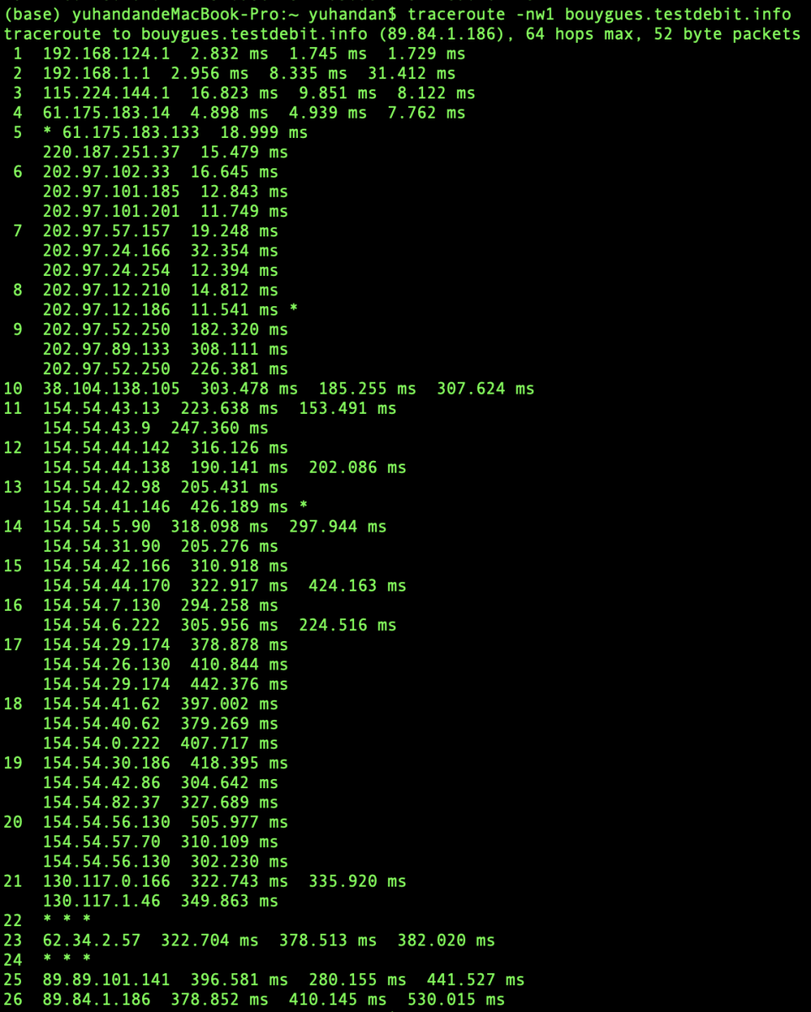

* traceroute speedtest.wtnet.de

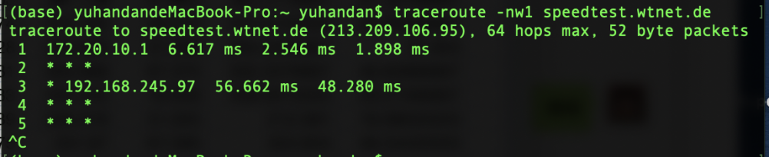

* Traceroute iperf.astra.in.ua

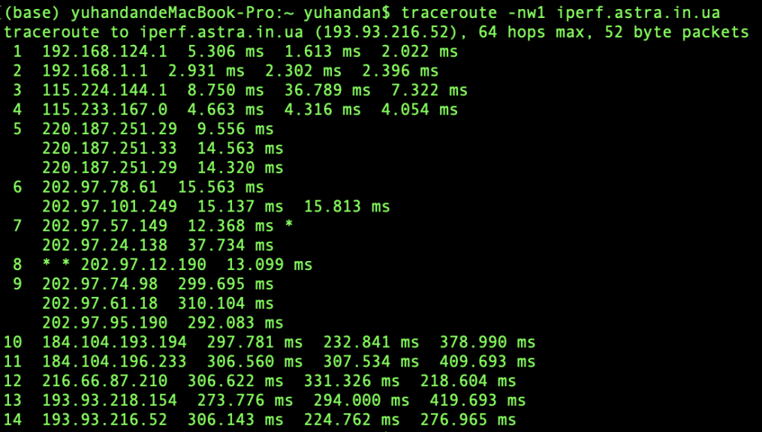

* Traceroute ping-90ms.online.net

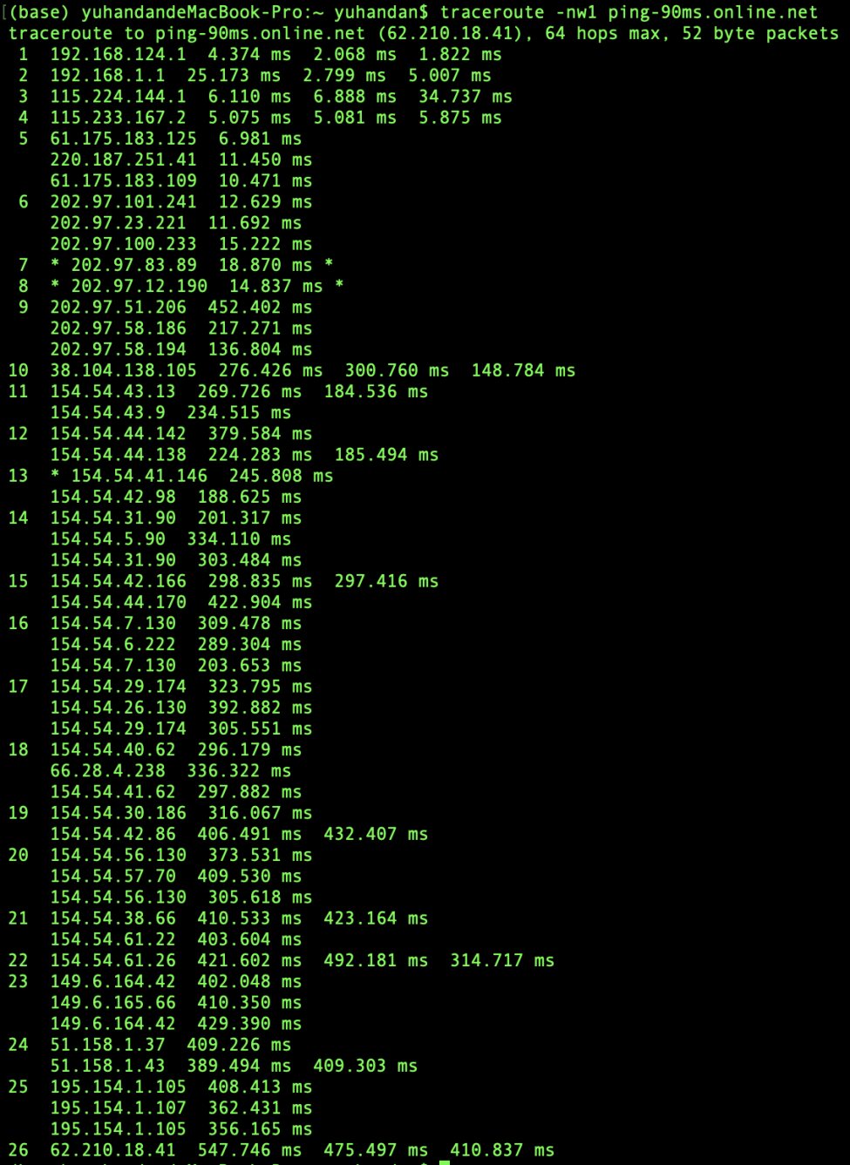

* Traceroute iperf.scottlinux.com

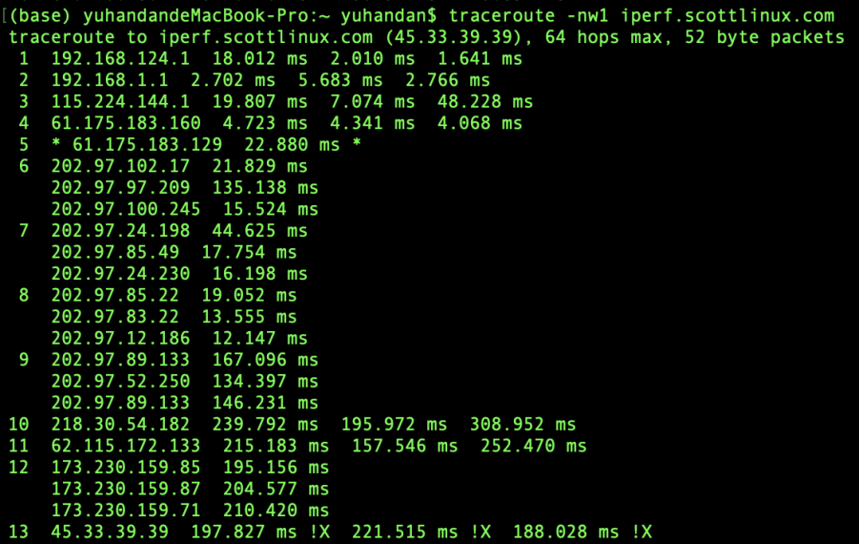

* Traceroute speedtest.serverius.net

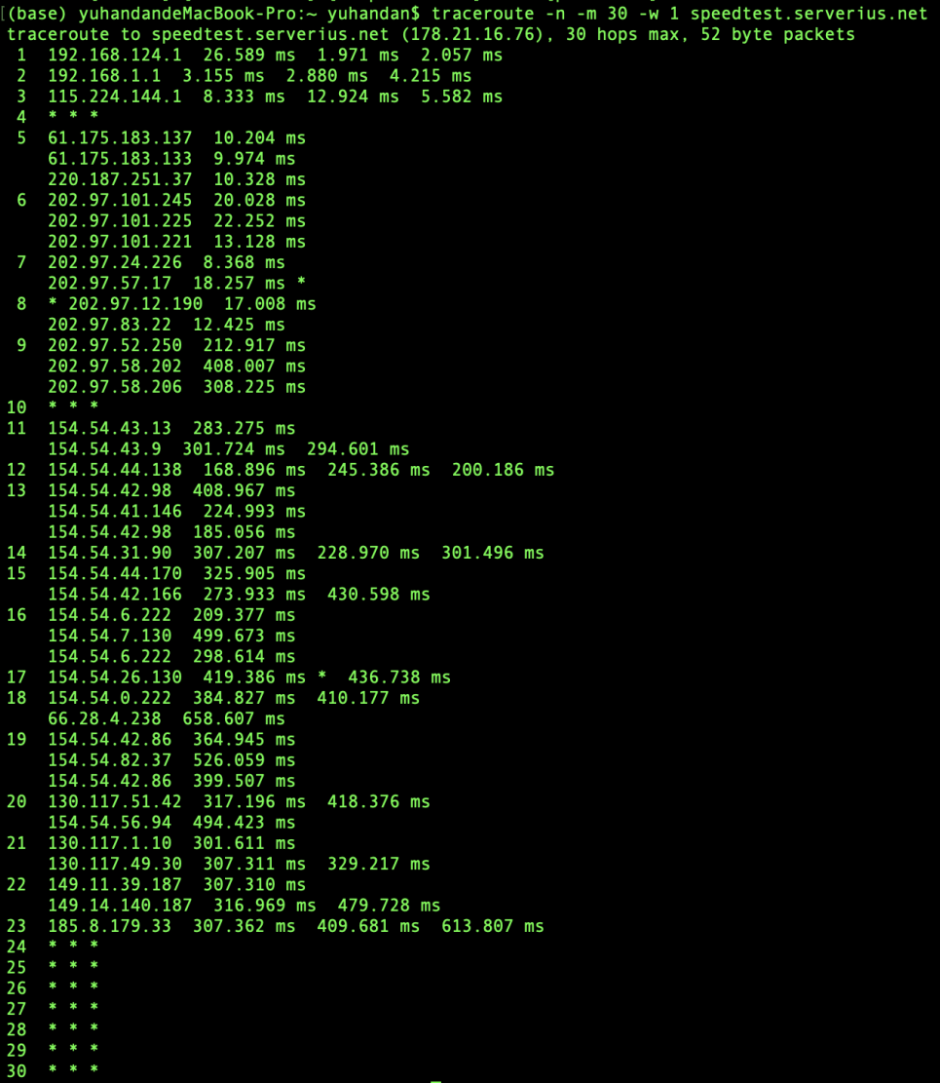

* Traceroute iperf.volia.net

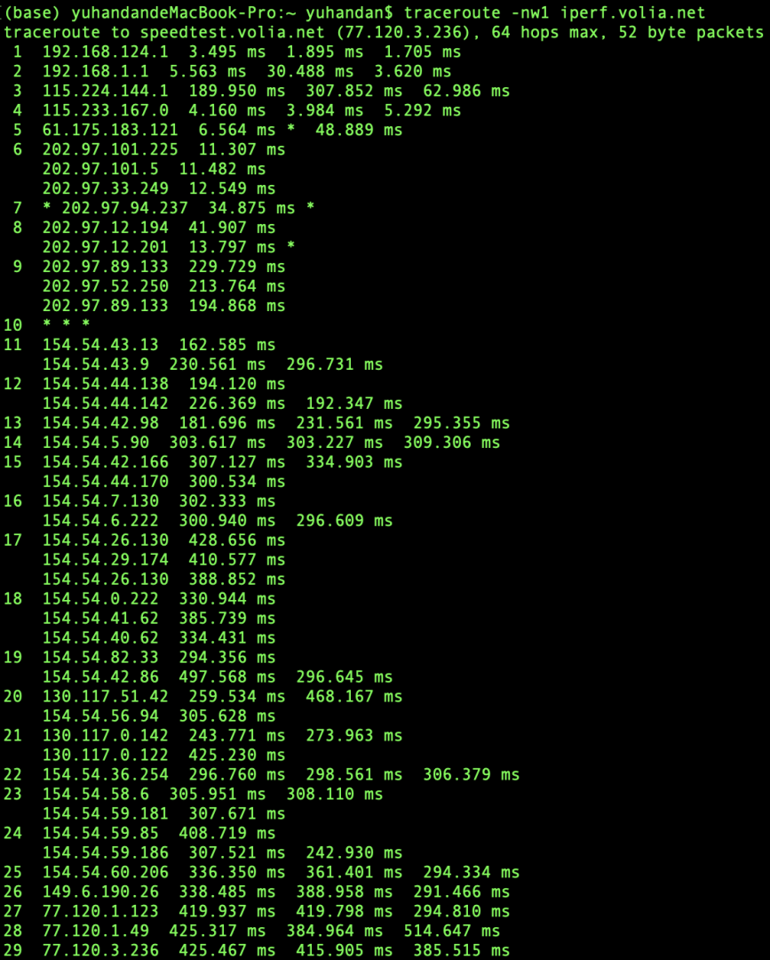

* Traceroute lille.testdebit.info

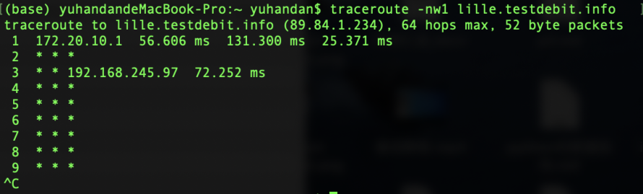

* Traceroute ping.online.net

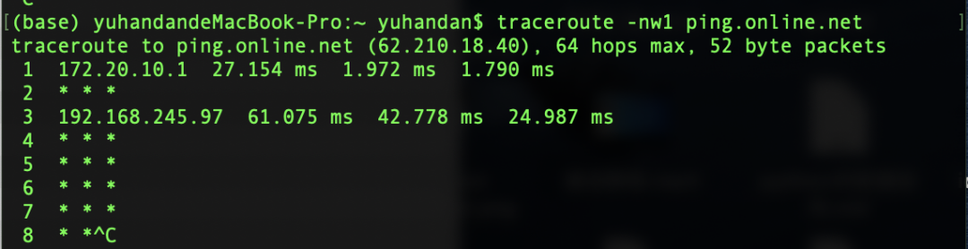

* Traceroute iperf.scottlinux.com

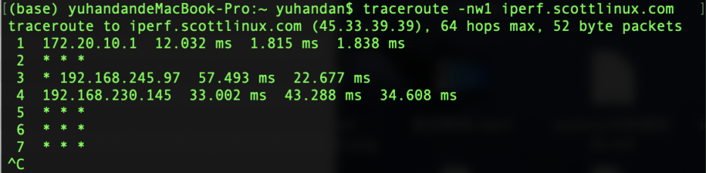

**Calculation and recording**

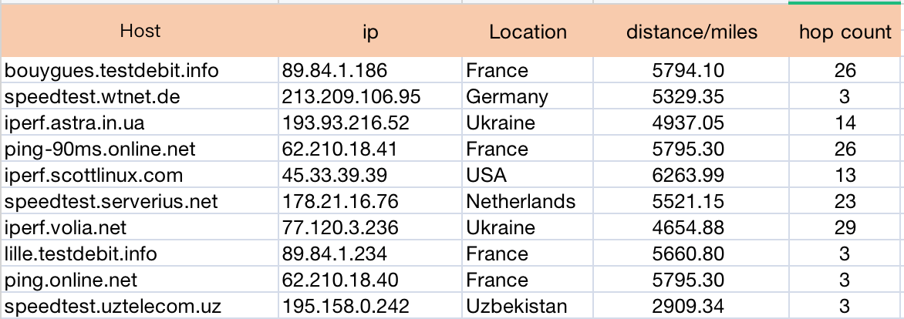

Section 3

* ping bouygues.testdebit.info

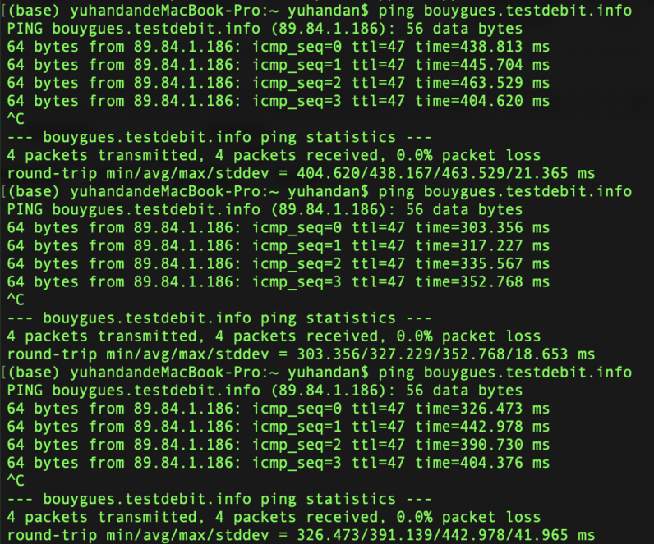

* ping speedtest.wtnet.de

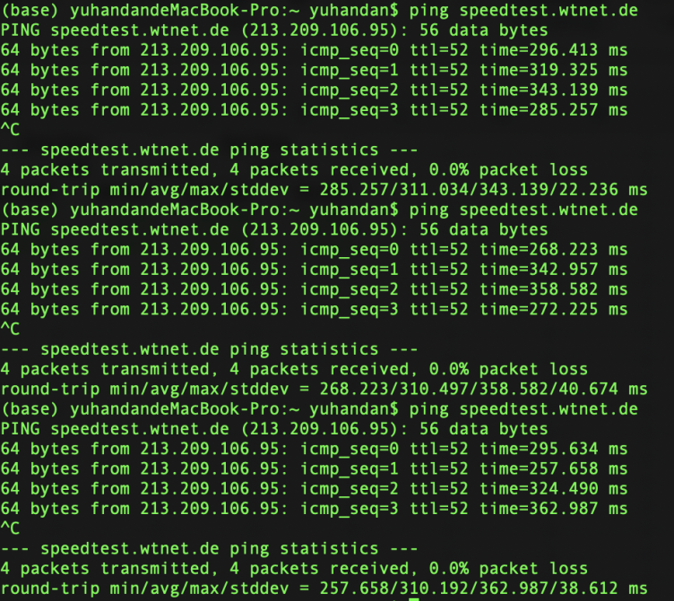

* ping iperf.astra.in.ua

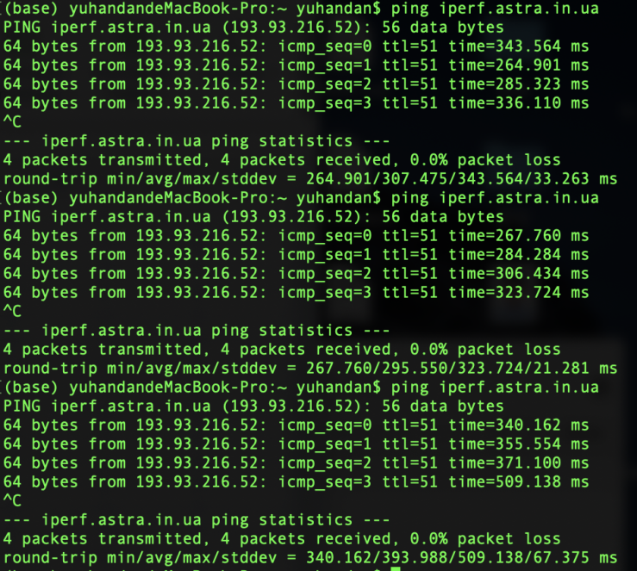

* ping ping-90ms.online.net

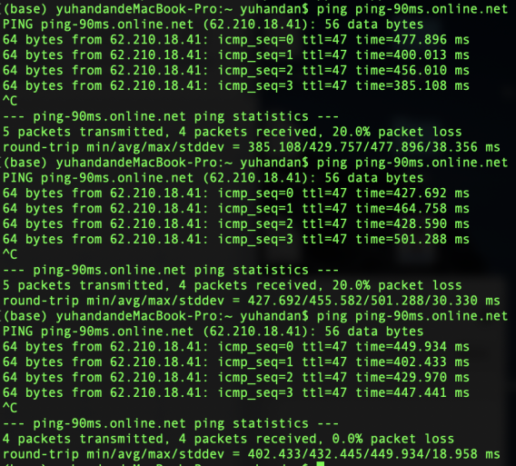

* ping iperf.scottlinux.com

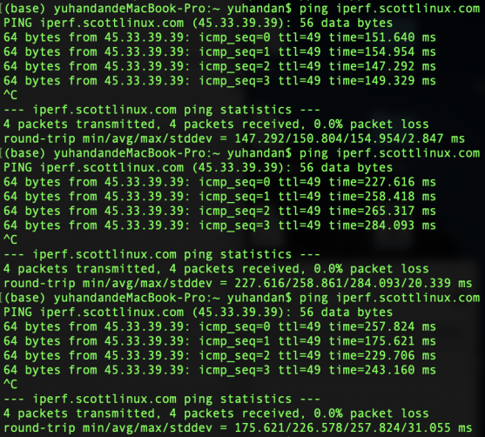

* ping speedtest.serverius.net

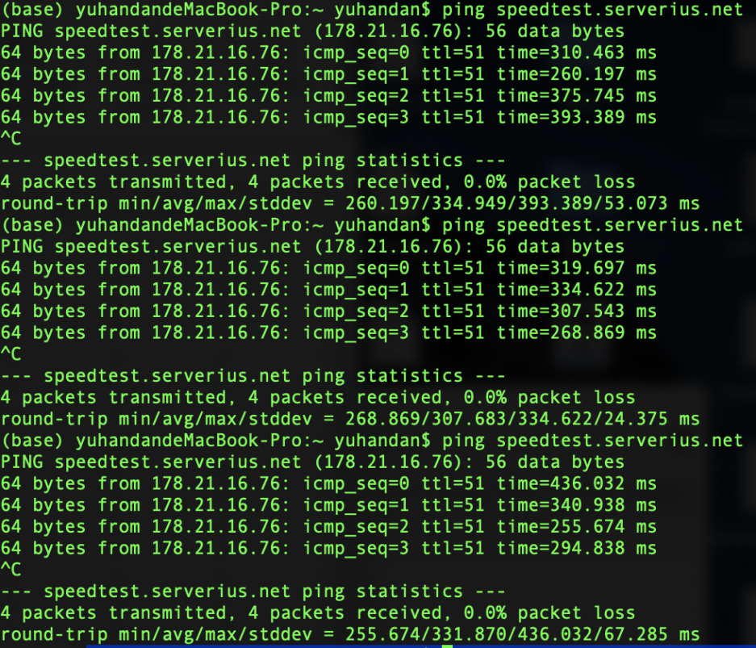

* ping iperf.volia.net

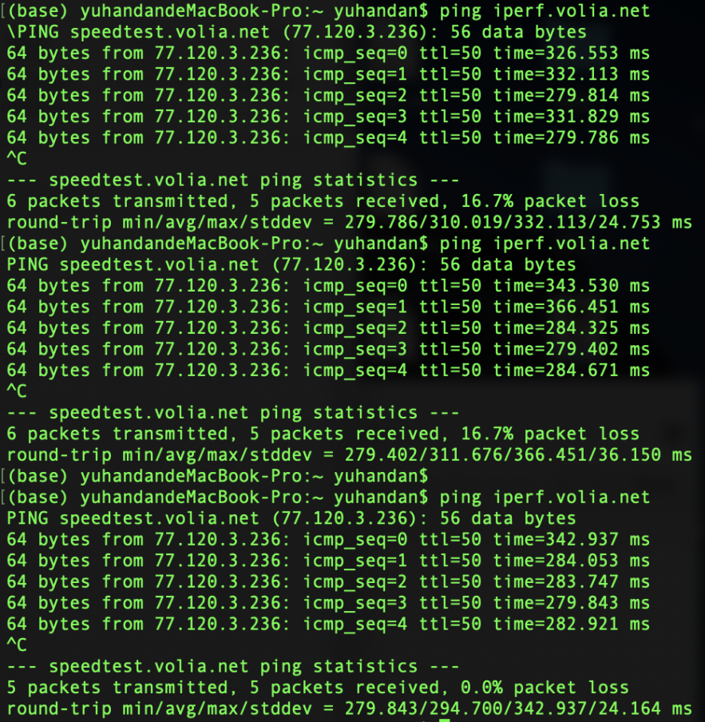

* ping lille.testdebit.info

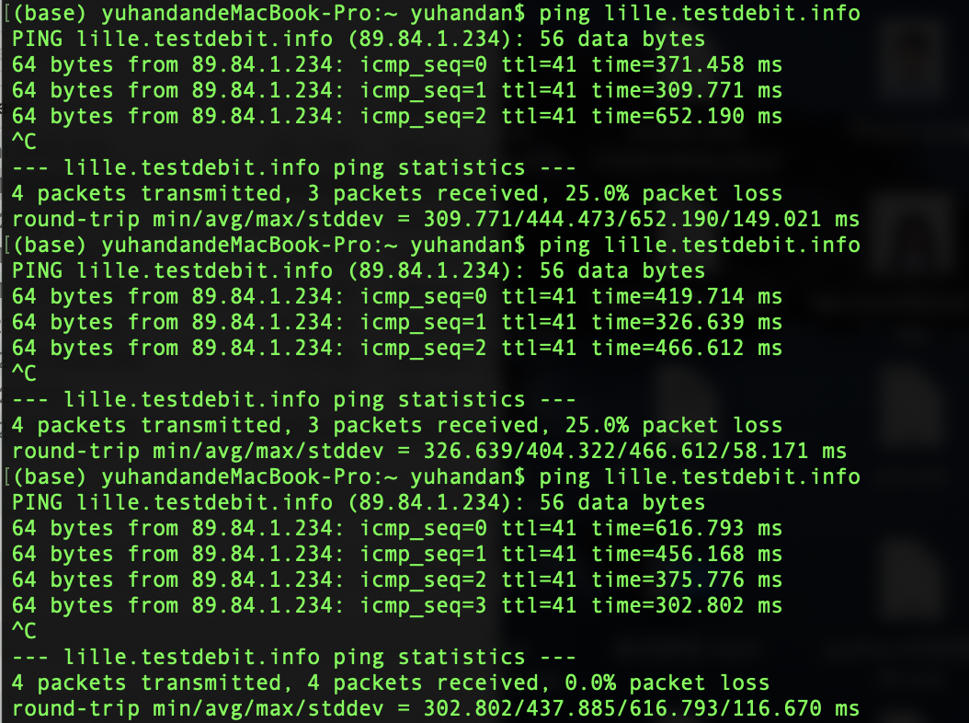

* ping ping.online.net

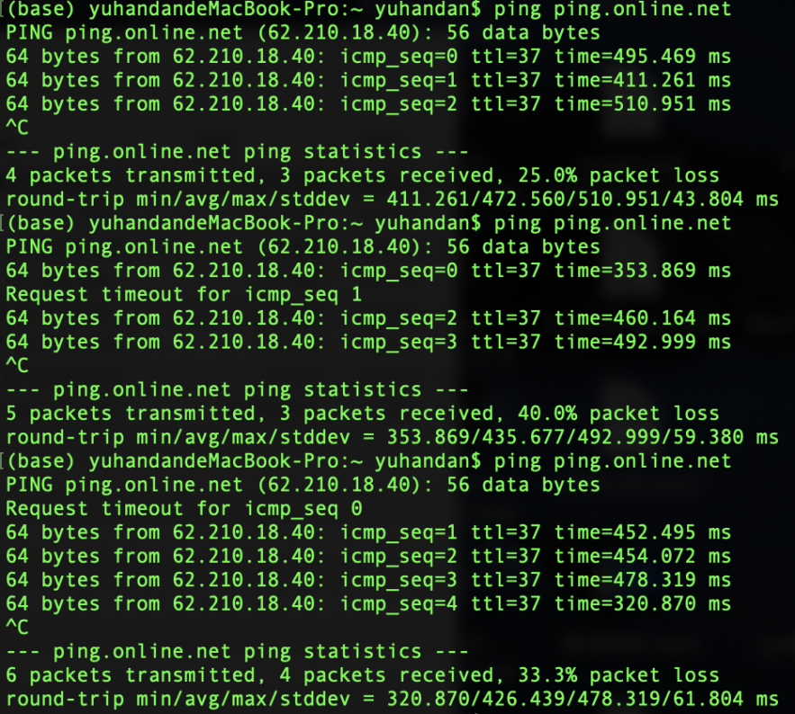

* ping speedtest.uztelecom.uz

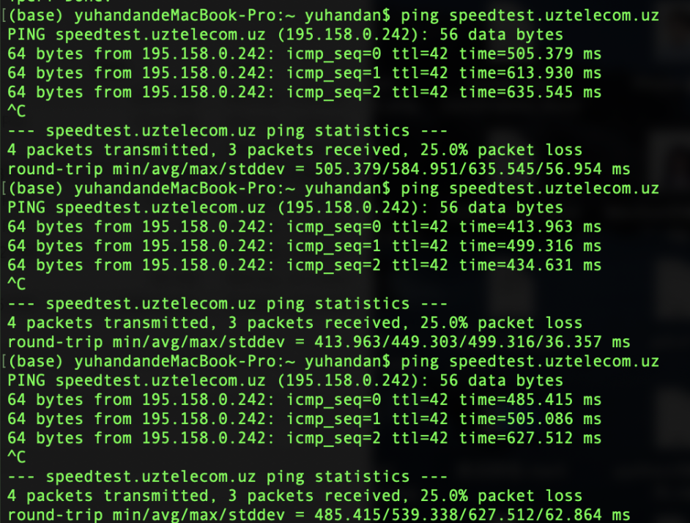

<Calculations>

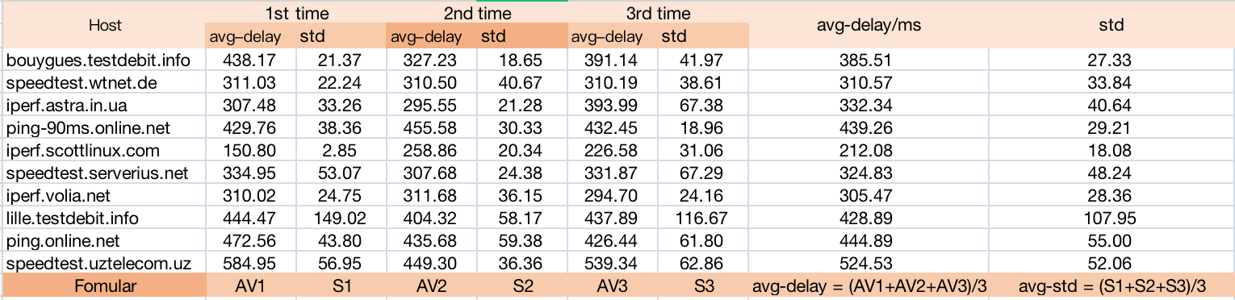

Because I can get the standard deviation directly from terminal command, I need only to compute the average of these three round-trips’ standard deviation of each host respectively to gain average standard deviation of each host.

Section 4

<Insert Images of results – screenshots of terminal/cmd>

* 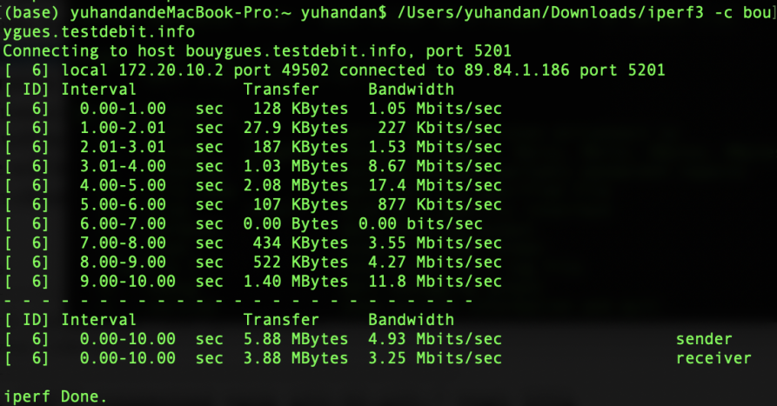bouygues.testdebit.info

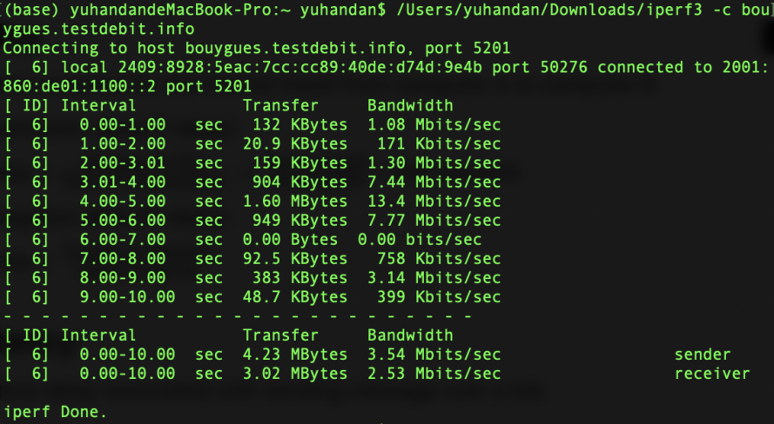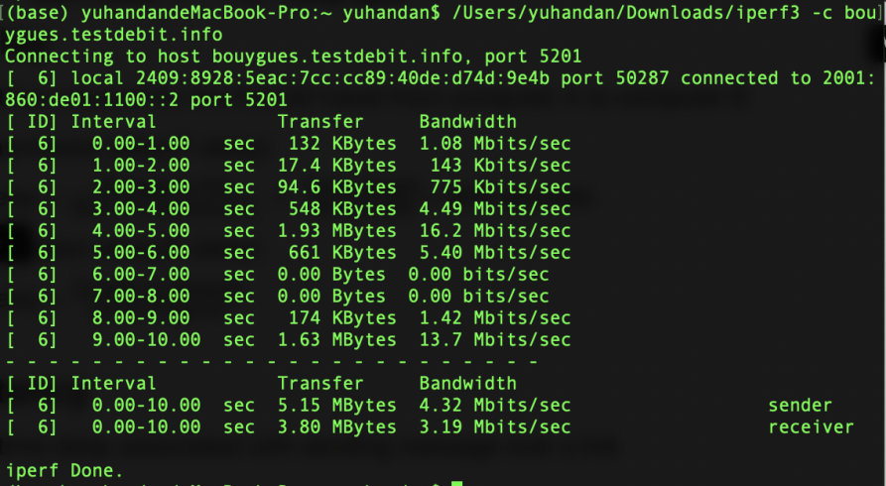

* speedtest.wtnet.de

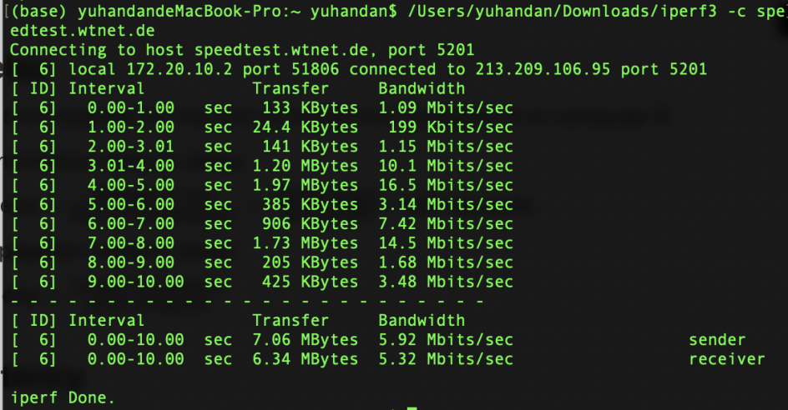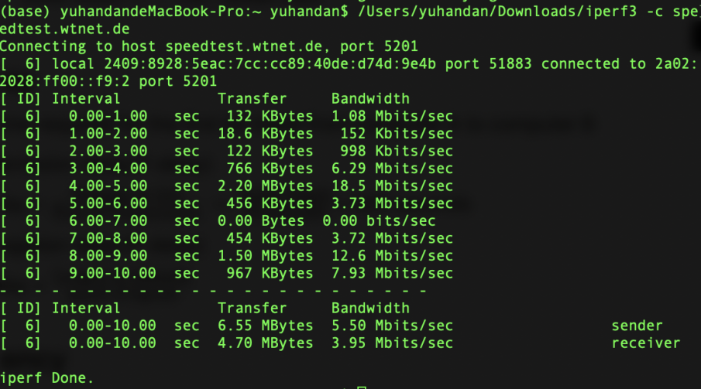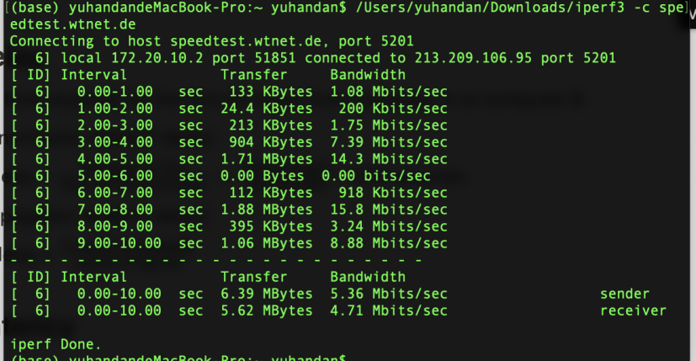

* iperf.astra.in.ua

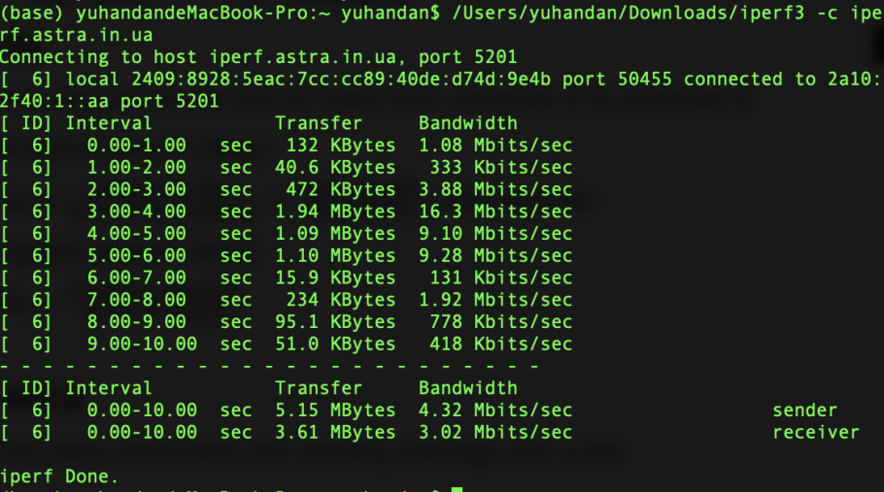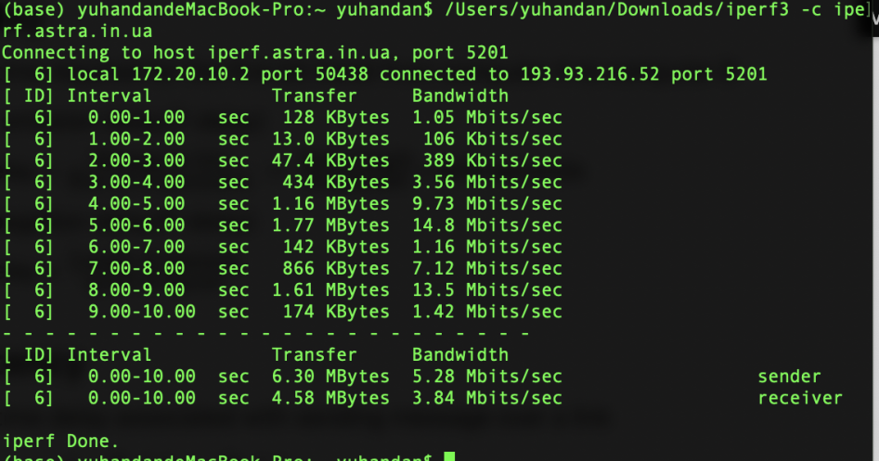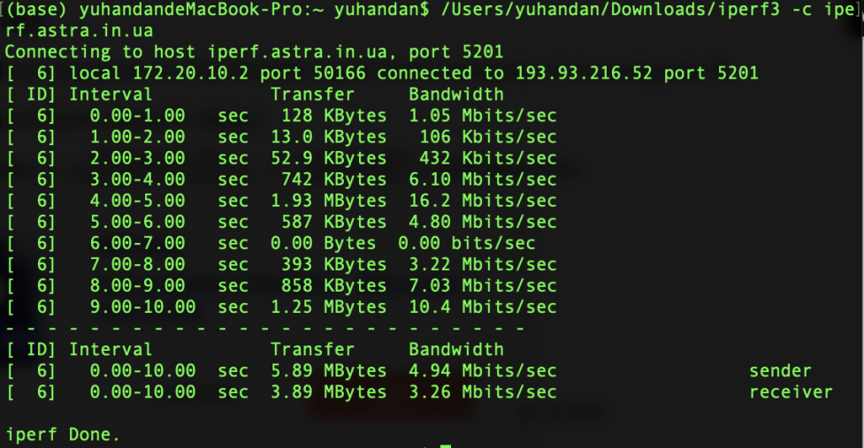

* ping-90ms.online.net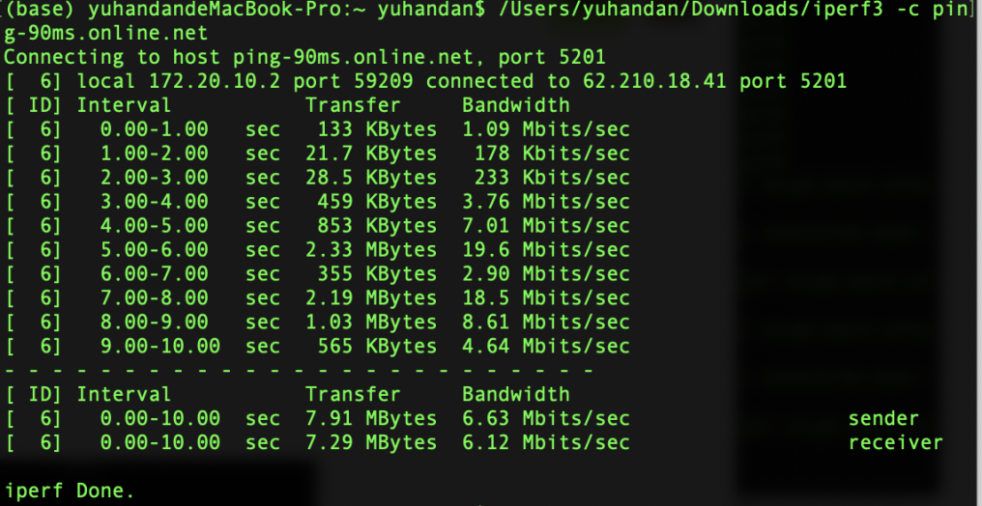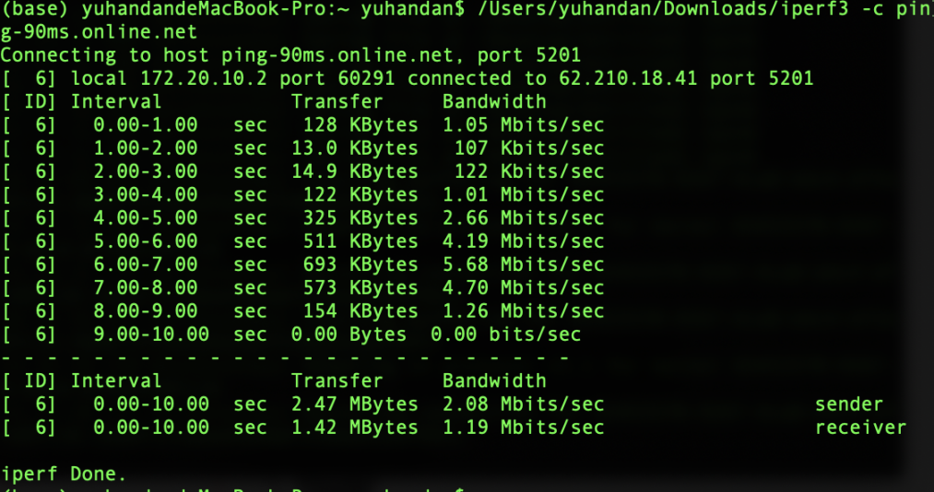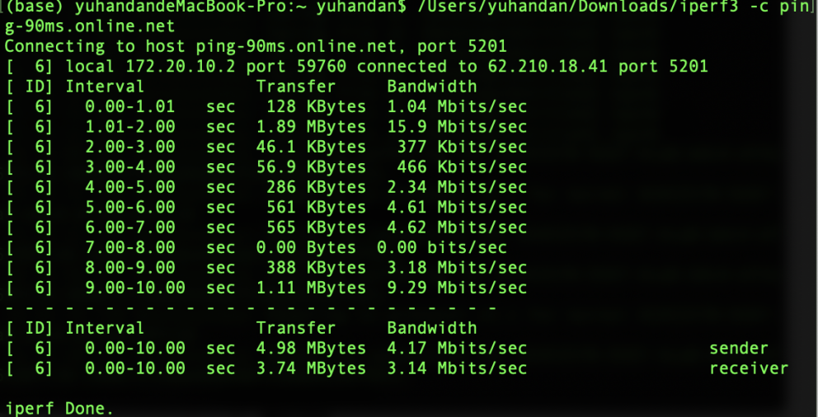
* iperf.scottlinux.com

<Insert Calculations>

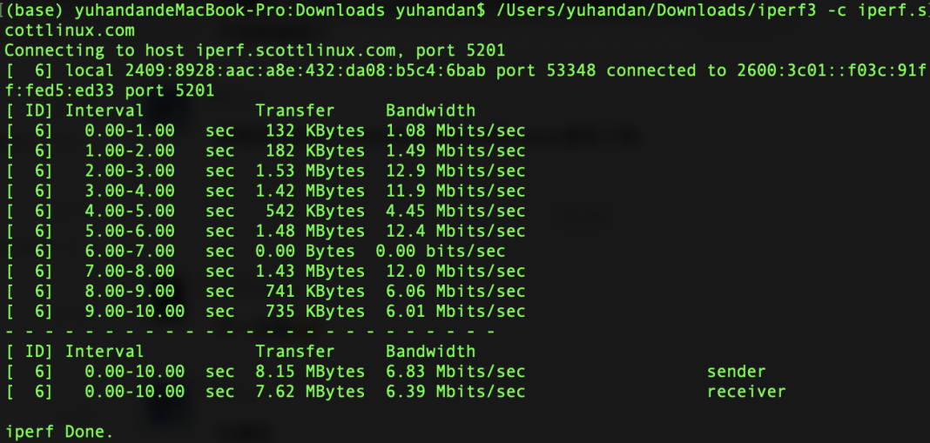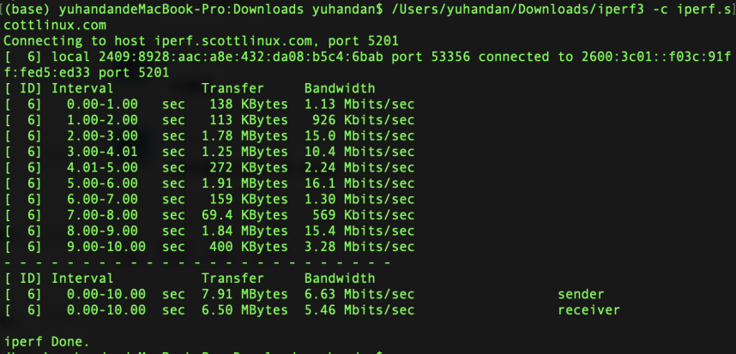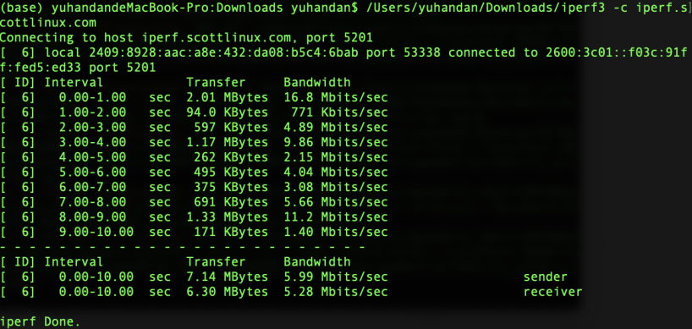

* speedtest.serverius.net

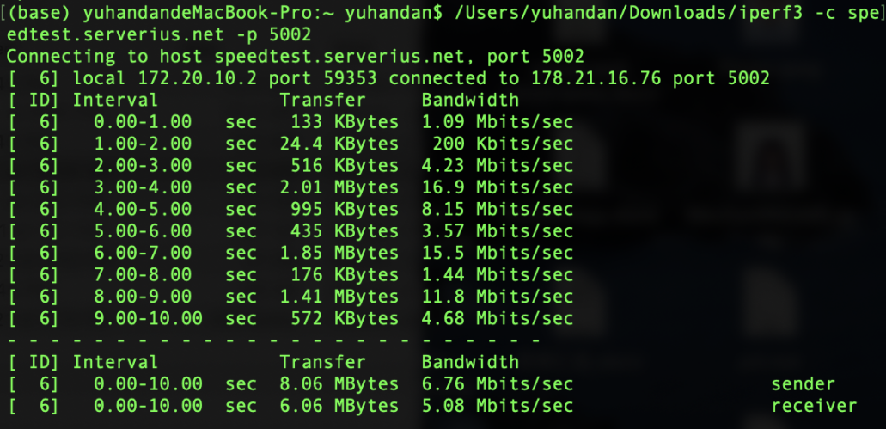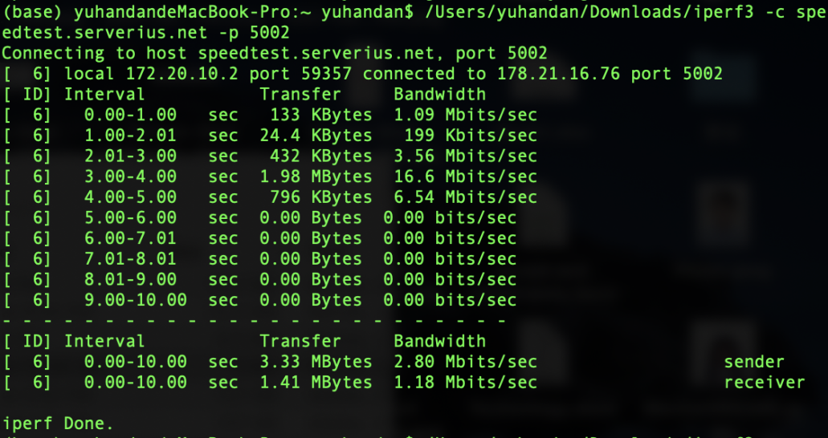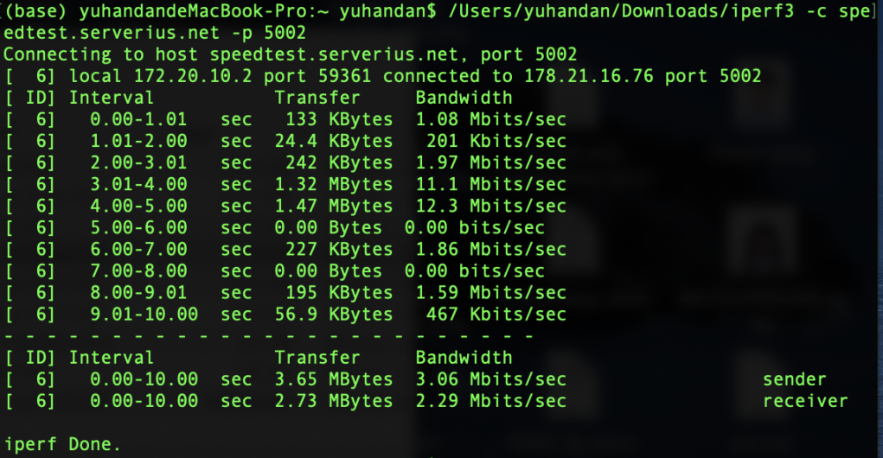

* iperf.volia.net

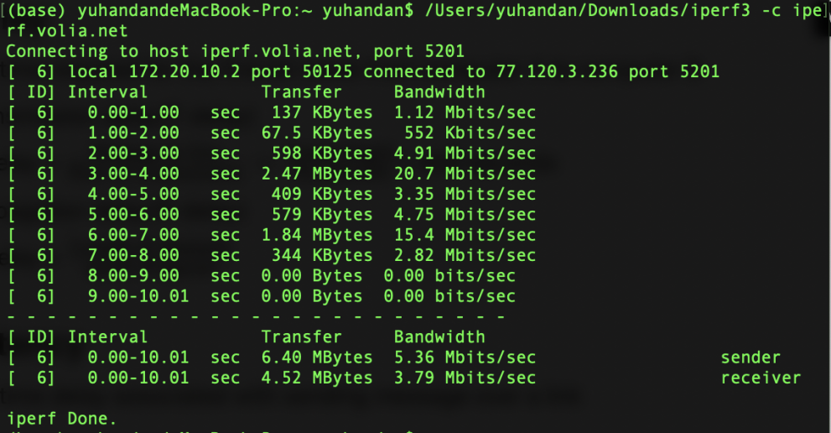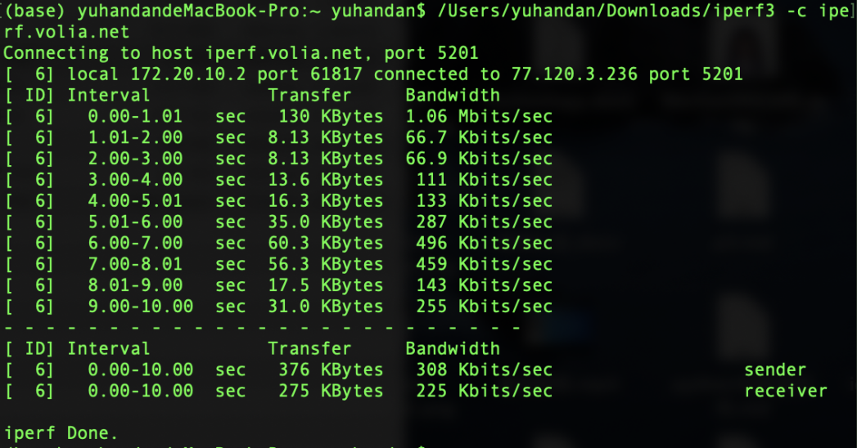

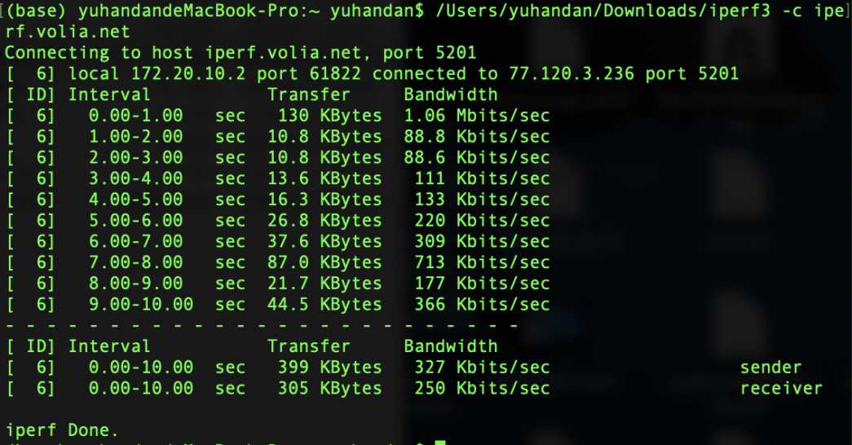

* lille.testdebit.info

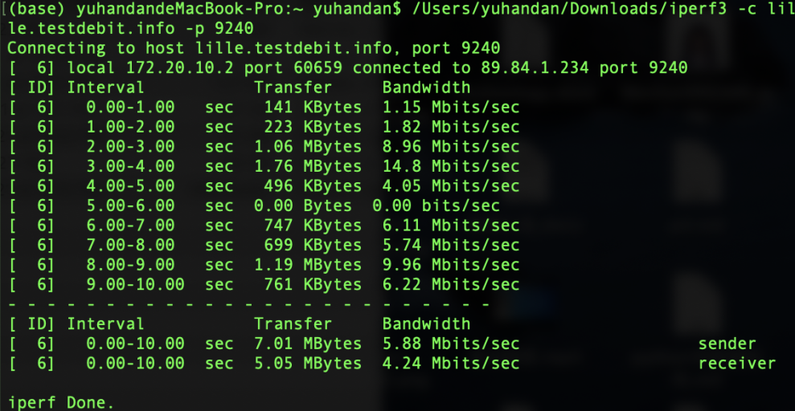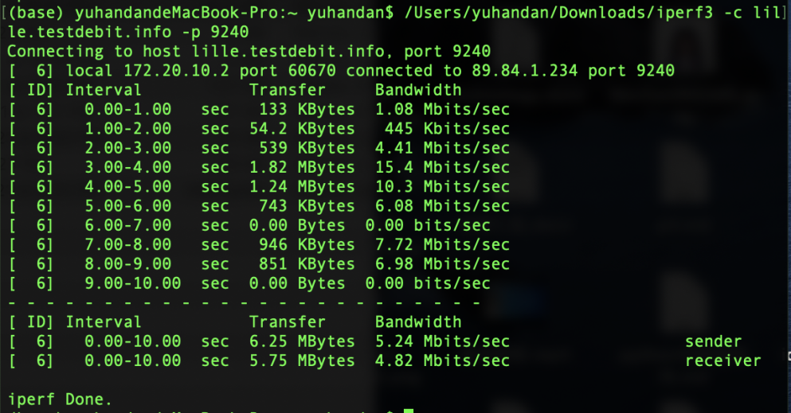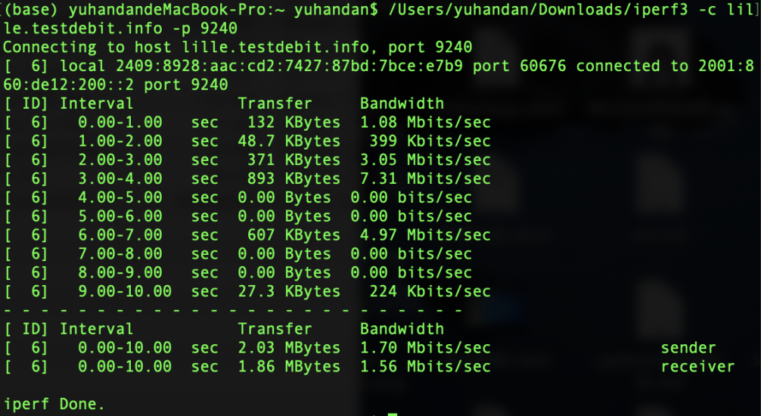

* ping.online.net

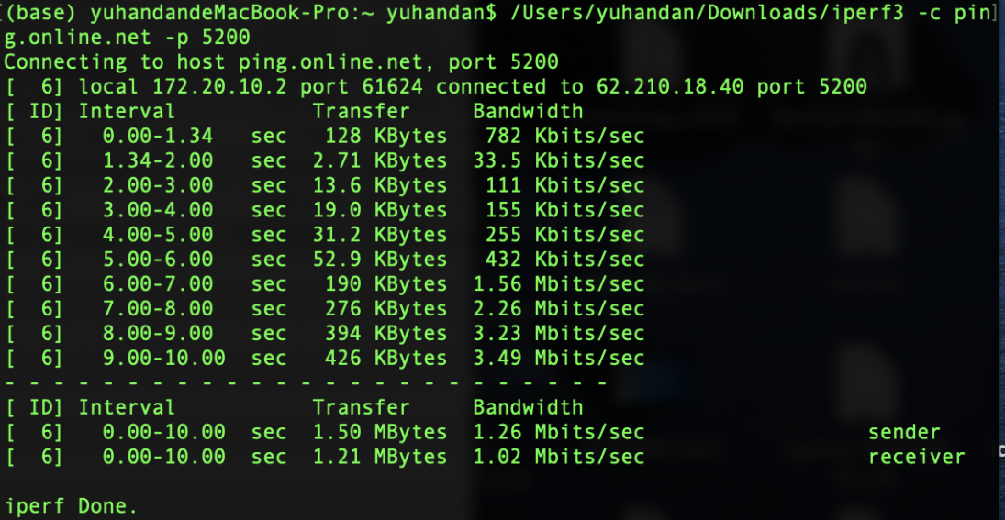

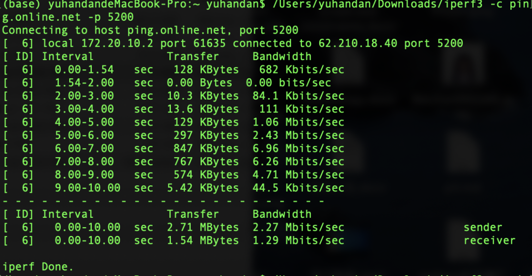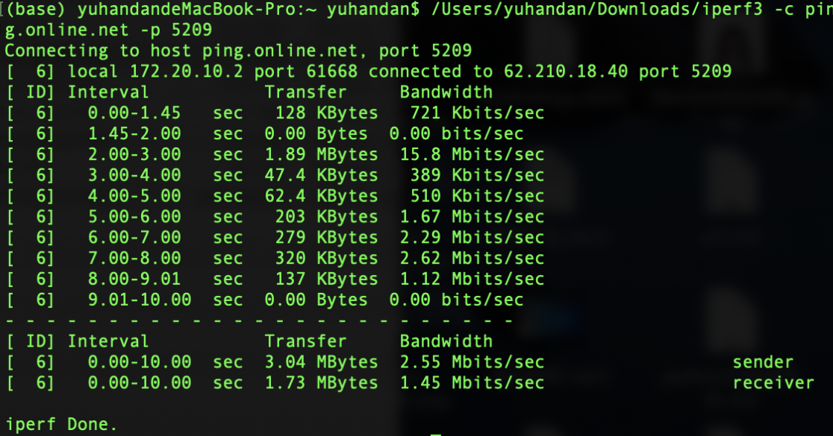

* D

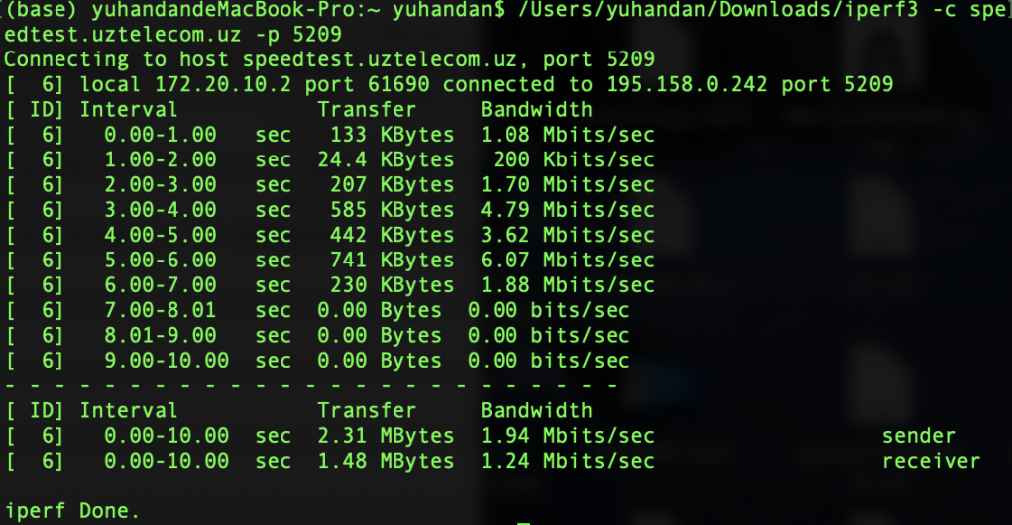

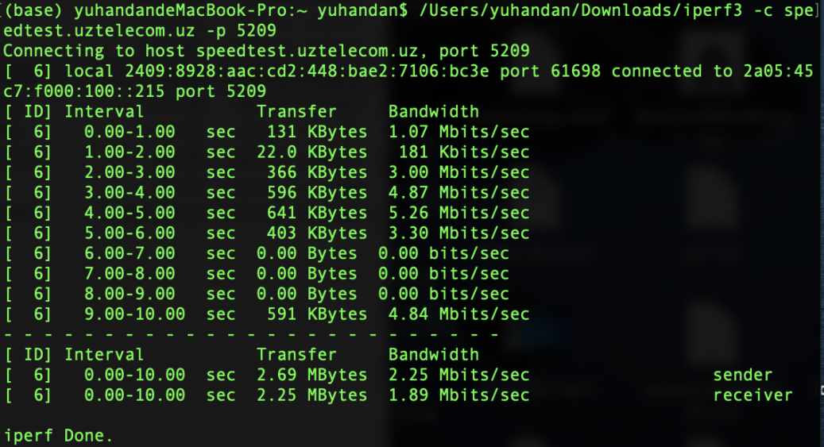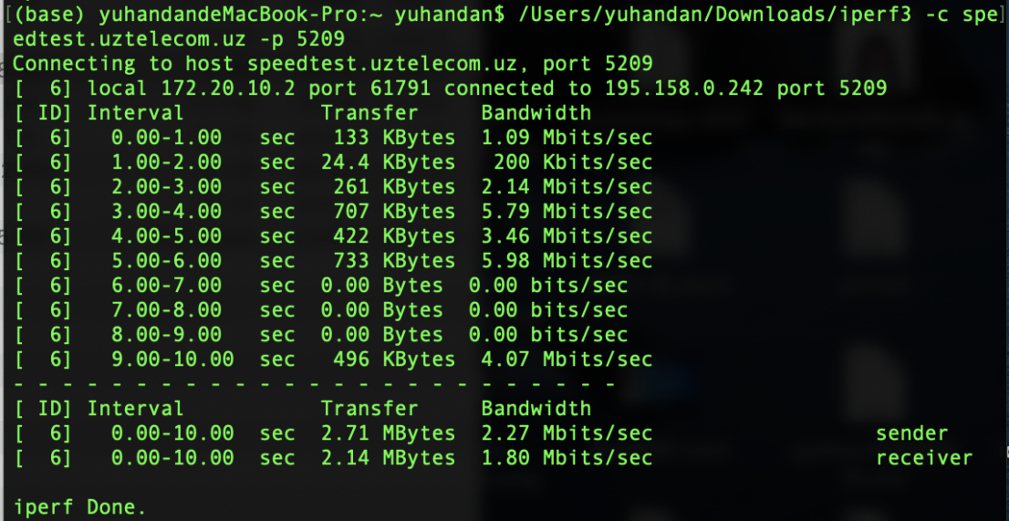

Calculation

